UAS avionics task-1
-Rohni
26/A13/027
Progress log:
1st sept: I refreshed my basic knowledge on python by watching a few videos on functions and loops, researched about matplotlib and A* algorithm I started working in VS studio and got started with the grid parsing and coding the structure of the grid.
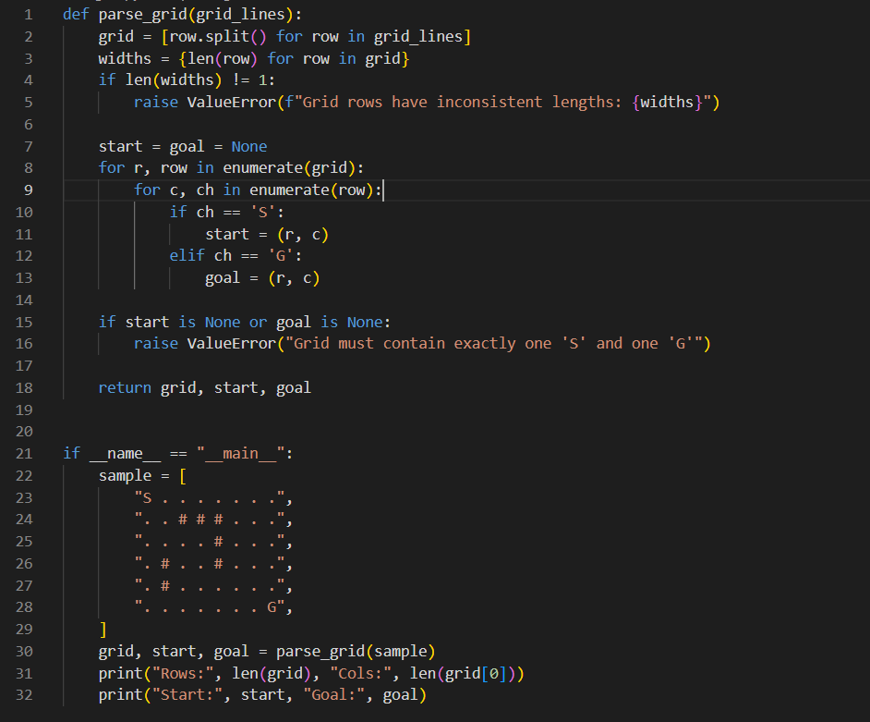
Next up I defined the graph/grid edges, and over here this function encodes the function to be able mov in 4 directions without any obstacles in the path.
This function drives the rules of movement, it finds which of the 4 directions can the uav move to and checks if the next cell is a movable cell or an obstacle.
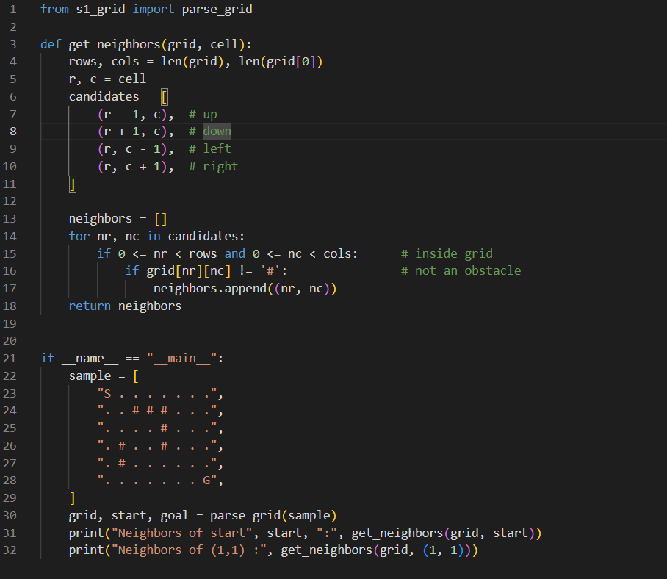

Next..
I learnt more about Manhattan distance in A* and how it estimates the remaining distance from the goal

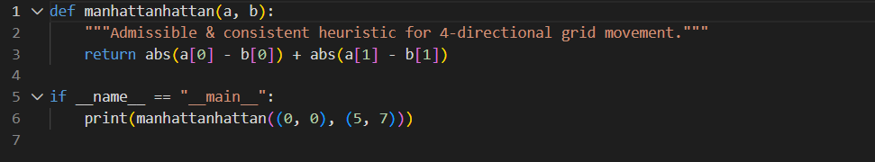

Next function
this is the main part of the function over here returns the path & its cost, nodes explored and it keeps doing it until it reached the goal.

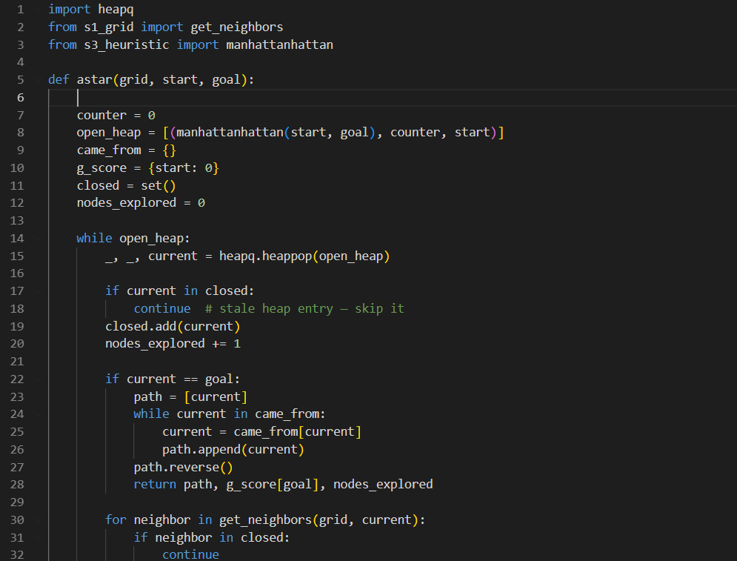
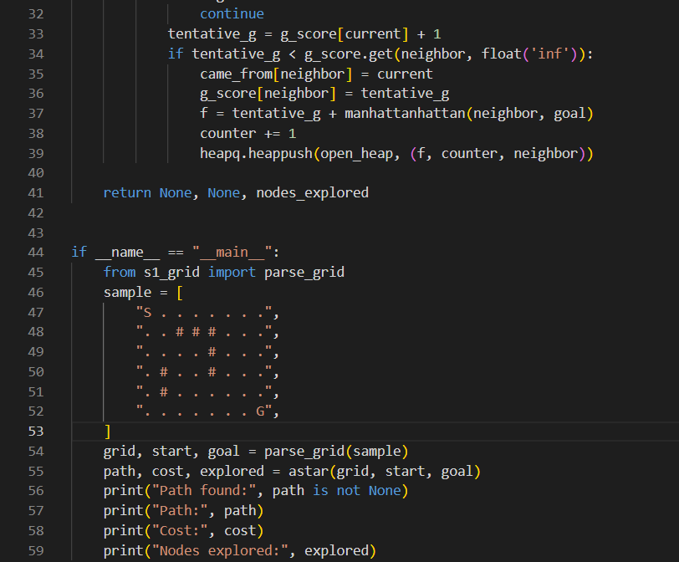

The visualising of the grid into a proper picture
It takes the final result of the search and turns them into a picture using matplotlib and numpy.
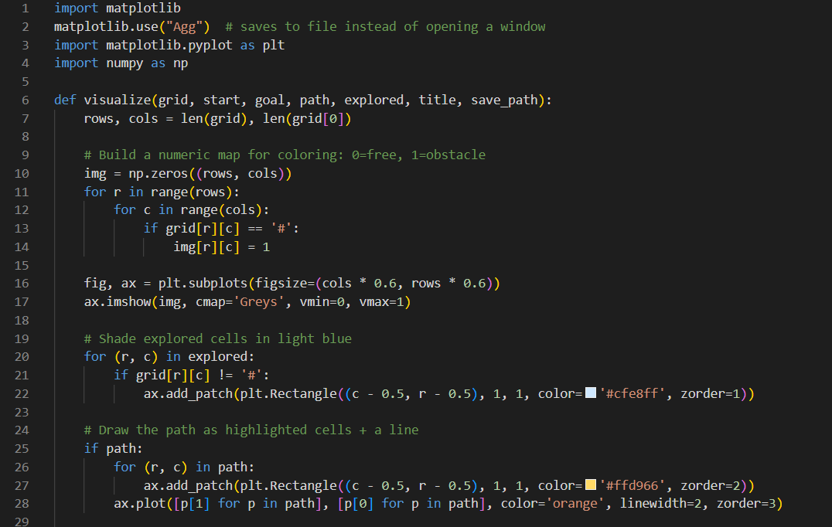
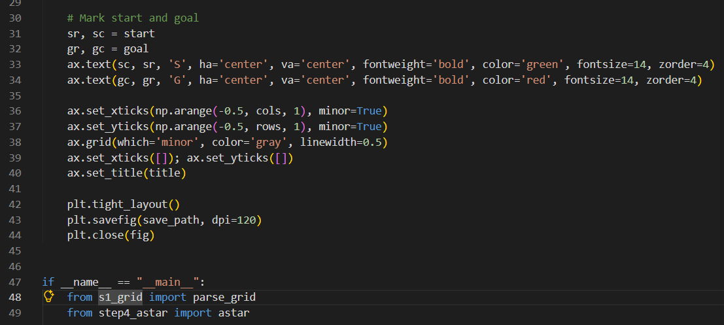
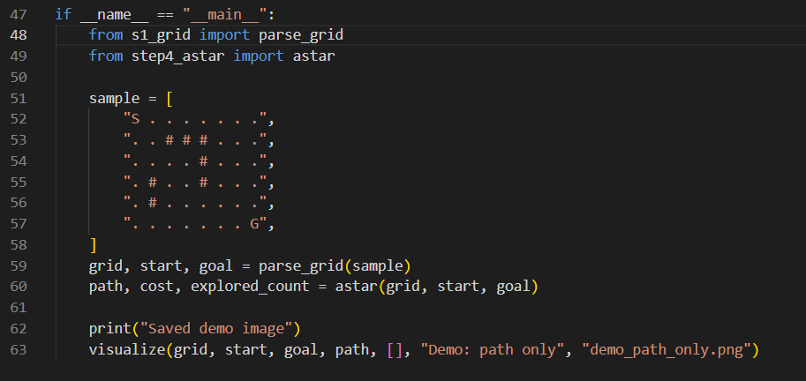
The Running part
5th sept: This was the most exciting part of this whole project when everything finally tied together to a piece. This part just formats the results into log lines and triggers the visualisation above.
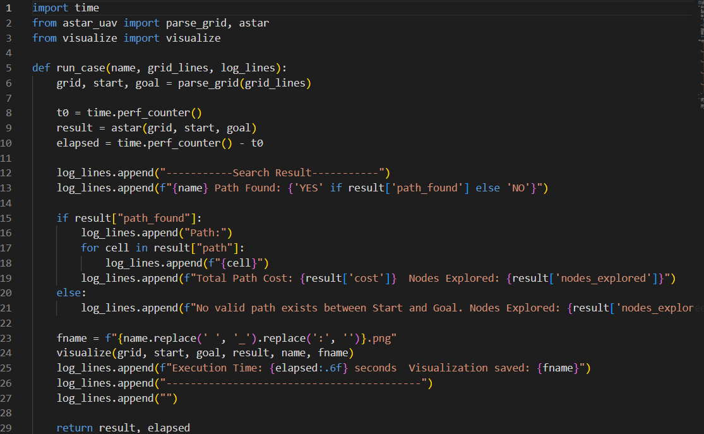

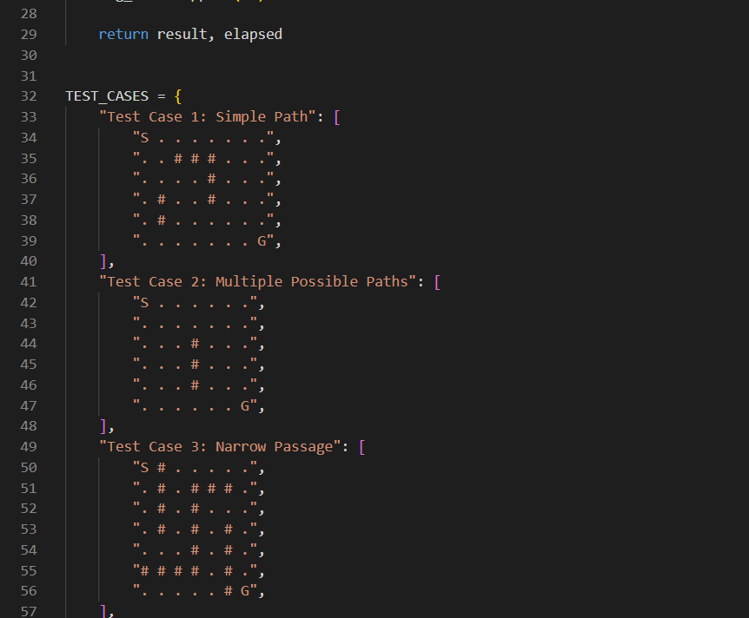
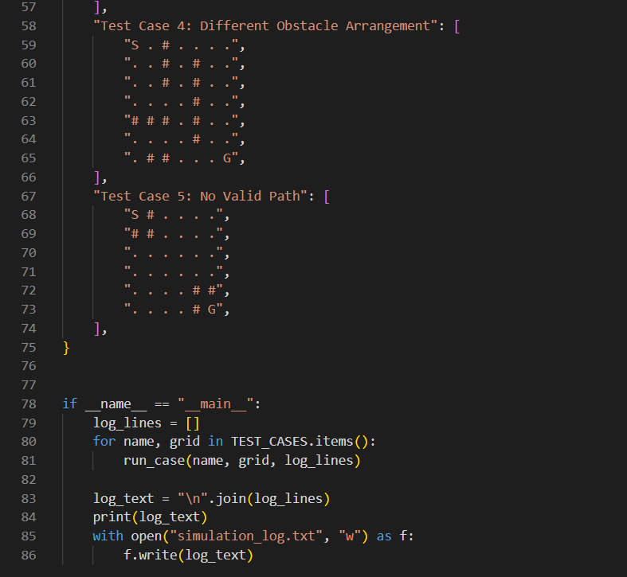
A* Theory
A* is a best-first search algorithm that finds the lowest-cost path between two nodes in a graph. It maintains a priority queue (the “open list”) of nodes still to be explored, always expanding the node that currently looks most promising. “Most promising” is defined using three quantities:
- g(n) — the cost of the best known path from the start node to node n so far. In this grid, since every move costs 1, g(n) is simply the number of steps taken to reach n .
- h(n) — a heuristic estimate of the remaining cost from n to the goal. This is a guess, not an exact measurement, computed without regard to obstacles.
This heuristic is appropriate for four-directional movement because : it never overestimates the true remaining cost to the goal. Since the UAV can only move one row or one column at a time, the absolute minimum number of moves needed to cover a given row/column distance — ignoring obstacles — is exactly the Manhattan distance. Any obstacles in the grid can only force a longer, more roundabout path; they can never make the true shortest path shorter than this estimate. Because the heuristic never overestimates, A* is guaranteed to return the truly optimal path, not merely a reasonable one.
- f(n) = g(n) + h(n) — the total estimated cost of a path through n . A* always expands the node in the open list with the lowest f(n) .
Test cases and results
Five test cases were used, covering the categories required by the task: a simple path, a grid with multiple possible routes, a narrow passage, a differently-arranged obstacle layout, and a case with no valid path.
- Test Case 1 — Simple Path. An open 6×8 grid with a small cluster of obstacles between the start and goal. Path found: yes. Total path cost: 12. Nodes explored: 41. Execution time: ~0.00008s. The path cost of 12 exactly matches the Manhattan distance between S and G, meaning the optimal path never needed to detour around any obstacle — the obstacles present did not block the shortest possible route.
- Test Case 2 — Multiple Possible Paths. A largely open grid with a single vertical wall of obstacles that can be gone around either above or below. Path found: yes. Total path cost: 11. Nodes explored: 39. Since the grid is open on both sides of the wall, several equal-cost routes exist; A* returns whichever one its expansion order reaches first, not necessarily a “preferred” one, since all equal-cost paths are equally optimal.
- Test Case 3 — Narrow Passage. A maze-like layout with a single winding corridor connecting S and G. Path found: yes. Total path cost: 20. Nodes explored: only 21 — very close to the path length itself. This is a direct illustration of how A* behaves when there is little to no branching: because the corridor offers almost no alternative routes to consider, the search barely explores any cell that isn’t part of the eventual path.
- Test Case 4 — Different Obstacle Arrangement. A grid with obstacles arranged in a different, more scattered pattern. Path found: yes. Total path cost: 12. Nodes explored: 16 — even fewer than Test Case 1, despite a similar path cost, because the heuristic guided the search almost directly toward the goal with very little wasted exploration in this particular layout.
- Test Case 5 — No Valid Path. The start cell is completely walled in by obstacles on all sides. Path found: no. Nodes explored: 1 (only the start cell itself, since it has zero legal neighbour to expand into). This confirms the algorithm correctly detects and reports an unreachable goal rather than looping indefinitely or crashing, terminating as soon as the open list is exhausted
Assumptions
- Each move (up, down, left, right) costs exactly 1, with no variation in cost based on direction or terrain.
- Each grid contains exactly one S (start) and one G (goal) cell.
- The grid is rectangular — every row contains the same number of cells.
- Diagonal movement is not permitted, consistent with the task specification.
- The UAV occupies a single cell at a time, it is also considered as a point object here.

